Module: IN2033 – UG Stage 2 Team Project
Project: InfoPharma Ordering System (IPOS)
Team:
Project Manager: Furqan Khokhar
Deputy Project Manager: James Cahill
Minute-taker: Huzefa Farooq

1. Client Meeting
Date: Tuesday 3 February 2026
Duration: Approximately 1 hour
Location: Client meeting (recorded session)
Attendees: Furqan Khokhar, Bahja, Dawud

Discussion
- Team representatives met with the client to clarify system expectations and raise project-related questions.
- The meeting was recorded for internal team reference.
- Information gathered will be shared with the full team to support requirements analysis and system design decisions.

2. Team Meeting
Date: Wednesday 4 February 2026
Duration: 48 minutes
Location: WhatsApp (online)
Chair: Furqan Khokhar
Minute-taker: Huzefa Farooq
Attendees: All team members
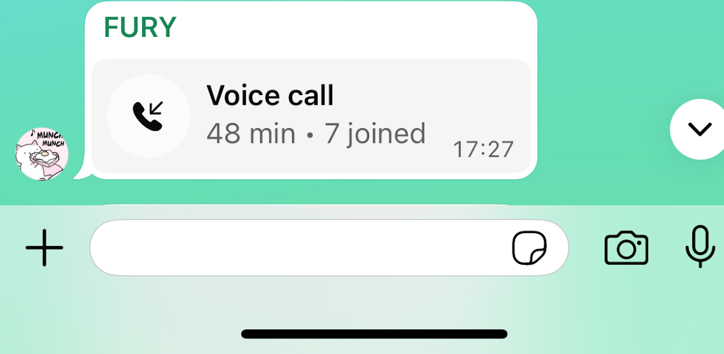

Agenda & Discussion
1. Project progress and initial deliverables
- The team agreed to begin work on the first project deliverable.
- Initial system design activities were prioritised, focusing on UML diagrams.
2. Design approach
- Discussion held on the use of use-case diagrams versus user stories for capturing requirements.
- It was agreed that UML design work would begin while the final requirements approach is confirmed.
3. Project planning and documentation
- A project binder was created to centralise documentation.
- A Gantt chart was produced outlining the project timeline and milestones.
- Tasks were assigned to members, with detailed allocations stored in a shared Google document.
4. Meetings and communication
- The team discussed communication channels and future meeting scheduling.
- A consultant meeting was planned, aiming for attendance by the full team.
Next Meeting: To be confirmed.

3. Consultant Meeting
Date: Friday 6 February 2026
Location: University consultant session
Consultant: Konstantin
Attendees: Bahja (team representative)

Discussion
- Consultant emphasised that consultant meetings are compulsory and attendance is monitored.
- Consultant indicated meetings should primarily involve the Project Manager and Deputy Project Manager, but full team attendance is expected where possible.
- Any team member not contributing to project work should be reported through the appropriate team channels if necessary.
Next Consultant Meeting:
- Date: Thursday 12 February 2026
- Time: 16:00
- Location: Room A401
- Expected Attendees: All team members except Faisal and Huzefa (Huzefa absence communicated due to medical reasons).

4. Cross-Team PM / DPM Coordination Meeting
Date: Monday 9 February 2026
Location: PM/DPM coordination session

Discussion
- All teams confirmed development of Java-based REST APIs.
- Docker containers will be used to connect backend systems to front-end applications.
- Deliverables should be completed three days early (24 February, 12:00).
- Front-end development plans:
  - Team A and Team B: Desktop front-end (Java Swing / JavaFX).
  - Team C: Locally hosted web front-end (Electron) connected to backend.
- All teams confirmed to currently be in the Analysis phase.
- Agreement reached to include one component diagram per team.

Questions to Discuss
- Preferred frontend approach: desktop or web.
- Docker container configuration for Java backend and frontend integration.
- Clarification regarding “public orders” and interaction requirements in the report.
- Database choice: MongoDB vs MySQL.
- Consideration of Python/Flask instead of Spring Boot due to system complexity.

Actions
- Each team to create Docker containers for subsystem execution (team-specific leads responsible).

5. Upcoming Consultant Meeting
Date: Thursday 12 February 2026
Time: 16:00
Location: Room A401
Expected Attendees: All team members except Faisal and Huzefa (medical absence communicated).

